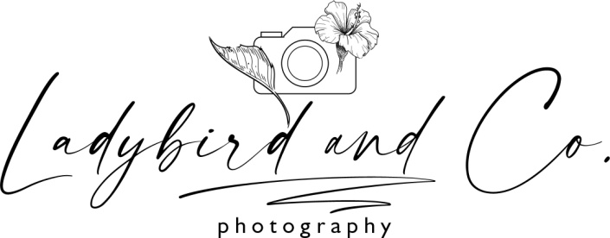

Terms and conditions

This agreement is between the Photographer Zsuzsanna Uzonyi-Balogh and the Client.
Payment:
A non-refundable booking fee of €100 will confirm your booking, as well as full acceptance of the terms and conditions as published on the photographer's website. The booking fee will be deducted from the cost of the client's chosen package when calculating the final balance due. The full price of the session contains the session fee and the chosen package fee.
Packages fees are not refundable outside exceptional circumstances.
When ordering wall arts, album or any other prints a 50% deposit must be paid at time of ordering. The balance is payable on the day of your collection.

Booking:
The Client will be required to sign the contract (via email or hardcopy). The Photographer will send an email as confirmation. The booking will then be considered Confirmed.
Once the Client has made a booking for a specific time and date and this date/time has been confirmed by The Photographer, The Photographer will not accept any other work from other clients for those times and dates.

Travel cost:
Lifestyle photography sessions has return travel fee outside of Drogheda approximately €0.70/km.
Cancellation:
In the event of cancellation of the portrait session by client the deposit are non-refundable. Deposit is transferable if a date change is necessary Forty eight (48) hours notice of cancellation is appreciated.
No refunds apply to cancelled sessions or no shows.
Due to Photographer’s illness or emergency, then the Photographer shall return the booking fee to the Client but shall have no further liability with respect to the Contract. This limitation on liability shall also apply in the event that photographic materials are damaged in processing, lost through camera or other media malfunction, lost in the mail, or otherwise lost or damaged without fault on the part of the Photographer.
Rejection:
Unless a rejection fee is agreed in advance, there is no right to reject the Images on the basis of style or composition.

Client accepts that all photographs will be taken and edited at the photographer’s discretion based on the photographer experience and aristic view.
The photographer reserves the right to immediately terminate service if the Client or Client's participates bully, harass, threaten, abuse, use violence, discriminate or makes offensive remarks towards the photographer or photographer’s brand.
The Photographer makes no guarantee with respect to any issue of quality, type, style, number of photographs, visual or artistic appearance of the final product. Every effort will be made to ensure that the Client receives the highest possible quality product. Many factors outside of the Photographers control contribute to the outcome of a session, variety of images captured, number of images presented and the subsequent visual and artistic appearance of photographs. Factors outside of the photographers control include but are not limited to:
Willingness and ability of photographic subjects
Newborn safety and temperament of photographic subjects
Natural features, expressions, positioning produced by photographic subjects
Time remaining in the event of lateness or non willingness to participate in a desired manner
Equipment and props available in the photographers existing collection
Time required to achieve specific images
Change of mind
Insisting on having services provided in a specific way against the photographers recommendation
Lab processing delays, shipping delays, printed product unavailability
Natural outdoor light and environmental conditions

Display:
Manipulation of the Images or use of only a portion of Image may only take place with the permission of the Photographer.
All images shall remain the sole property of the Photographer at all times
The client hereby allow the photographer to display any photograph covered by this contract and to generally promote the business in advertising, brochures, magazine articles, websites, sample albums etc.
Copyright of all images taken remains with The Photographer at all times. Commercial use of any images supplied by The Photographer is prohibited without prior consent. The Photographer reserves the right to use any of the images for promotional purposes.
All original digital files created by the Photographer remain the property of the Photographer. Should the Client request copies of images after initial delivery, the Photographer will, where possible, make them available for future reproduction in return for the relevant fee.

Digital images:
Proofing images will be made available to the Client to finalize selections in a private online meeting.
Final images will be ready within 1-3 weeks from the date of the session.

Prints:
Printed photographs are ready for collection within 2-3weeks from the date of the session.
The Client shall be responsible to supervise children at all times. The Photographer will not accept any responsibility due to any accident to children or damage to public or private properties during a shoot.
The photography studio is not suitable for large family group.
Newborn safety:
The Photographer adheres to best industry practice for newborn safety. The Photographer is experienced in all aspects of newborn safety and posing. Posed newborn photography is subject to safety and individual temperament. Wrapped positions are great for highly sensitive newborns, unsettled or awake newborns. The session is baby led and the Photographer cannot guarantee specific poses.
Sibling attendance:
Siblings will attend the newborn photography session in the first 40 minutes for family portraits and for newborn and siblings portraits. After the family portrait session family members are not allowed in the studio. The photographer will create calm and relaxing environment for the baby for the best newborn photography results. This will be the time to create single baby portraitures and mom and baby portraitures.
In the event of single baby portrait session siblings are not allowed in the studio.
Delivery of products:
The supply of products is provided of the photographer on the best endeavours basis. The photographer will not be liable for delays that are beyond her reasonable control. The photographer shall not be liable for any delays in meeting any of her obligations which were due to causes beyond her reasonable control included lab/ postage delay, government legislation, industrial action, adverse weather condition, fire, loss or damage in transit.
Price and terms:
All prices shown within the photographer’s price list are subject to change without prior notice. The photographer reserves the right to amend these terms and conditions without notice.
The due performance of this contract is subject to alteration or cancellation by either party owing to any cause beyond their control as in force majeure or the event of a total photographic failure.
A Force Majeure Event means an event beyond the control of a party, which by its nature could not have been foreseen or, if it could have been foreseen, was unavoidable, and includes, without limitation, acts of God, storms, floods, riots, fires, sabotage, civil commotion or civil unrest, interference by civil or military authorities, acts of war or armed hostilities or other national or international calamity or one or more acts of terrorism or failure of energy sources.
Communication:

The photographer provides the client 30 minutes pre-session consultation. The photographer will answer your questions regarding your portrait session included style guide, session guide.
All other communication must be made in writing by email. The Photographer is not liable for any messages sent by mobile text or social network websites.
Archiving:
The Photographer is obliged to archive images for 2 months from the date of the delivery of files.

.......................................................... ............................................................
Photographer Client

Date:

